Sennheiser launches Pro Talk homepage
Every captivating video interview plus extra material available in one place

Wedemark, August 15, 2019 – Ever wanted a one-to-one chat with a leading light in the world of professional audio? For the next best thing, Sennheiser’s award-winning Pro Talk Series features audio professionals sharing their insider tips and describing their paths to success. Now, Sennheiser has made this essential collection of video interviews available in one central location at www.sennheiser.com/protalkseries. As well as the series of Pro Talk videos, the new site also includes articles with key insights taken from the interviews to provide audio enthusiasts with a unique and valuable resource.

The “Pro Talk Series by Sennheiser” has already attracted a considerable audience on YouTube – and accolades have followed: The first season won a TEC Award for Outstanding Technical Achievement in 2018, and Season 2, which continues to bring viewers these outstanding profiles, has just been nominated for the 2020 TEC Awards.

“The Pro Talk Series is something we at Sennheiser are very passionate about. Our intention is to bring audio enthusiasts closer to the magic behind the curtain, so to speak,” said James Capparelle, Marketing Communications Manager Professional Audio and Producer of the Pro Talk Series. “The collection of these outstanding portraits, and the expertise of the audio professionals interviewed is a unique and valuable resource of information.”

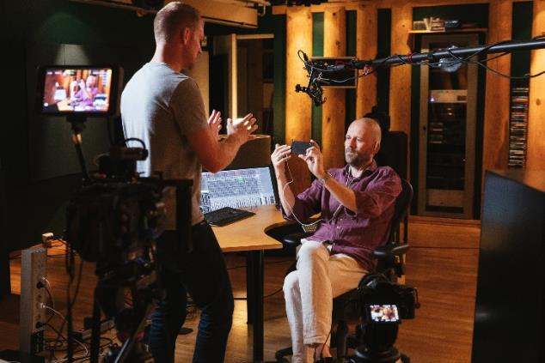 | On set: James Capparelle (left) interviewing Morten Lindberg, Norwegian recording engineer and music producer, as he demoes Sennheiser’s AMBEO Smart Headset

Virtually meet a live sound professional today
By visiting www.sennheiser.com/protalkseries, audio enthusiasts can discover remarkable stories from engineers, producers and other professionals whose passion and expertise has shaped successful careers in music production and live sound. Visitors can tap into a wealth of information, insider tips and expertise that makes the Pro Talk Series page a reference for audio devotees who would love to take time to virtually get to know some of the world’s most renowned producers, musicians and engineers.

The site provides brief introductions to each individual, allowing visitors to easily browse a broad range of professional disciplines and subject matters before going in depth with each expert in their video interviews.

For example, meet the highly successful Broadcast Music Mixer, Randy Faustino, who expresses his passion for music by saying: “I don’t know anything other than sound; it’s all I’ve ever been in love with... It’s in my blood, it’s in my heart, it’s in my soul.”

Broadcast Music Mixer Randy Faustino working on the final mix for the Season 16 finale of American Idol. Randy has worked with the likes of Kelly Clarkson, Elton John, the Bee Gees and many more | 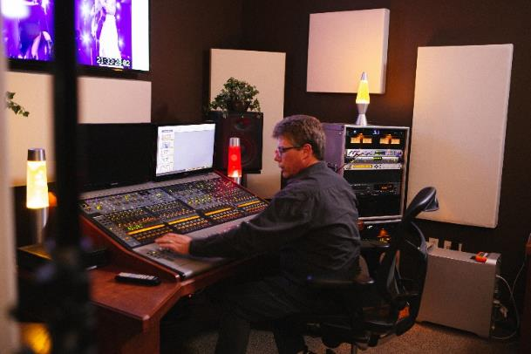

Or Leslie Ann Jones, Director of Music Recording & Scoring at Skywalker Sound, who shares her number one tip: “For younger people wanting a career in this business, I think that’s the best advice I can give: Spend time just listening to music… really listen to what someone’s trying to do, even if it’s the kind of music you could never see yourself doing, because you can always learn something from it.”

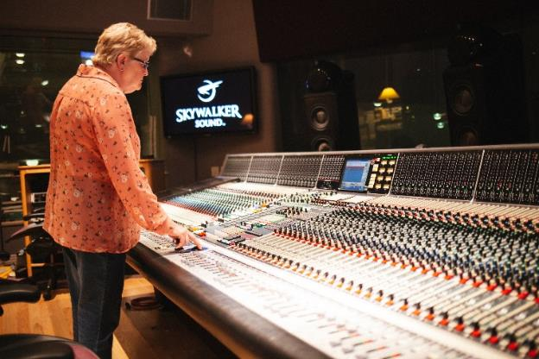 | Leslie Ann Jones, Director of Music Recording & Scoring at Skywalker Sound, in the control room of the Scoring Stage at Skywalker Ranch

The Pro Talk Season 2 includes interviews with:
- Axel Reinemer, Founder and Owner of Jazzanova Recording Studios – Berlin, Germany
- Blake Mills, Musician and Producer – Sound City Studios – Los Angeles, USA
- Oliver Bloch-Lanié and Nicolas Quéré – La Frette Studios – Paris, France
- Leslie Ann Jones – Director of Music Recording and Scoring at Skywalker Sound, San Francisco, USA
- Morten Lindberg – Recording Engineer and Music Producer – Oslo, Norway
- Mousse T. – Music Producer and Owner of Peppermint Park Studios – Hanover, Germany
- Randy Faustino – Broadcast Music Mixer – Los Angeles, USA
- Stéphane Reichart – Music Scoring Mixer – Paris, France
- Chris Jojo – Senior Sound Designer at Codemasters – Southam, UK
- Christian Peterson – Head of Sound at Cirque du Soleil: Corteo Arena
- Brandon Blackwell – Front of House Engineer for A$AP Rocky: Injured Generation Tour
- Simon Franglen – Composer – Los Angeles, USA

And some good news for those who want more: Production for Season 3 will begin in the early Fall of 2019.

Visit the Pro Talk Homepage at www.sennheiser.com/protalkseries.

Image Link
The high-res images of this press release can be accessed here: http://sennheiser-brandzone.com/pincollection.jspx?collectionName={b0feefe0-e7cb-463f-b656-697993d552d4}.

About Sennheiser
Shaping the future of audio and creating unique sound experiences for customers – this aim unites Sennheiser employees and partners worldwide. Founded in 1945, Sennheiser is one of the world’s leading manufacturers of headphones, loudspeakers, microphones and wireless transmission systems. Since 2013, Sennheiser has been managed by Daniel Sennheiser and Dr. Andreas Sennheiser, the third generation of the family to run the company. In 2018, the Sennheiser Group generated turnover totaling €710.7 million. www.sennheiser.com

Local press contact Global press contact

Jeff Touzeau Stephanie Schmidt
jeff@hummingbirdmedia.com stephanie.schmidt@sennheiser.com
+1 (914) 602-2913 +49 (5130) 600 – 1275

